# Jeffery. Dirden

ITAI 1370

# Professor Esmalifalak

# November 22, 2024

LAB L10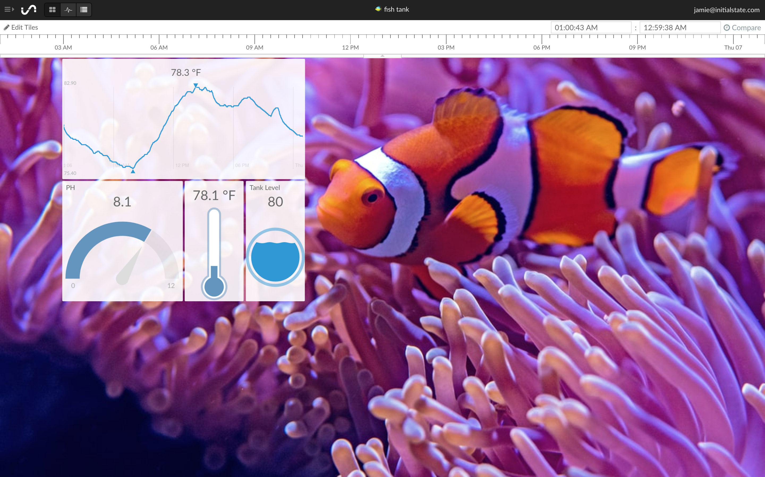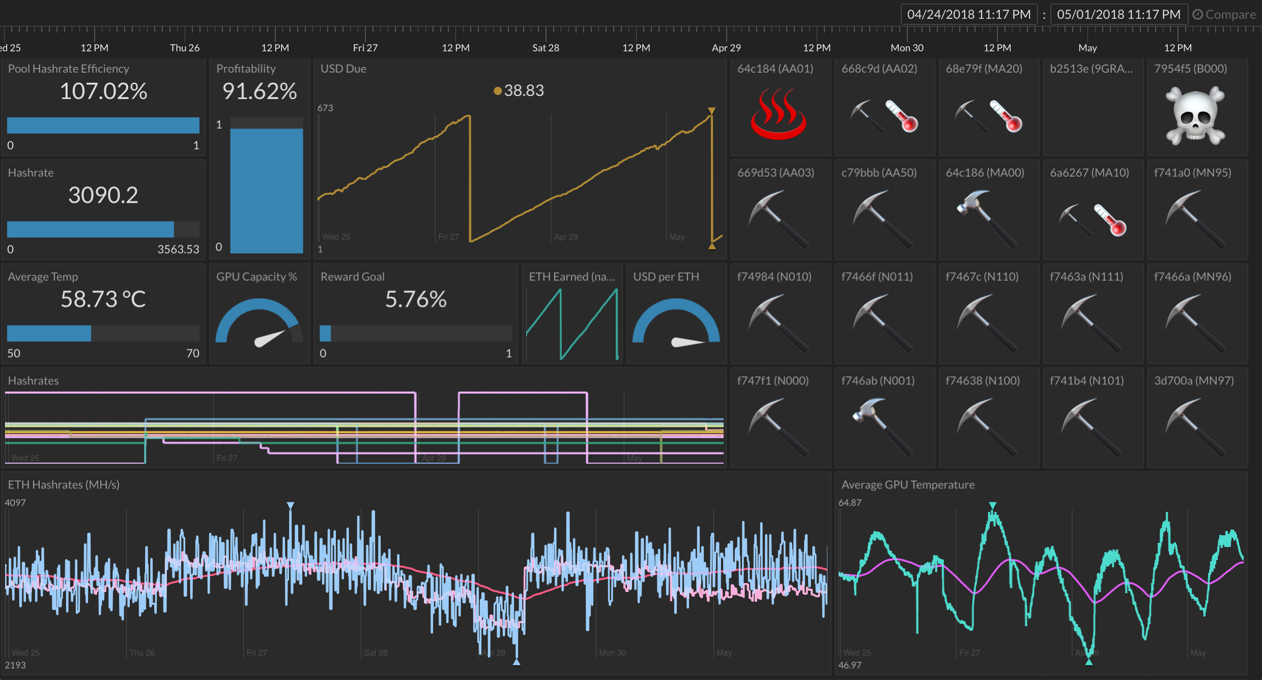

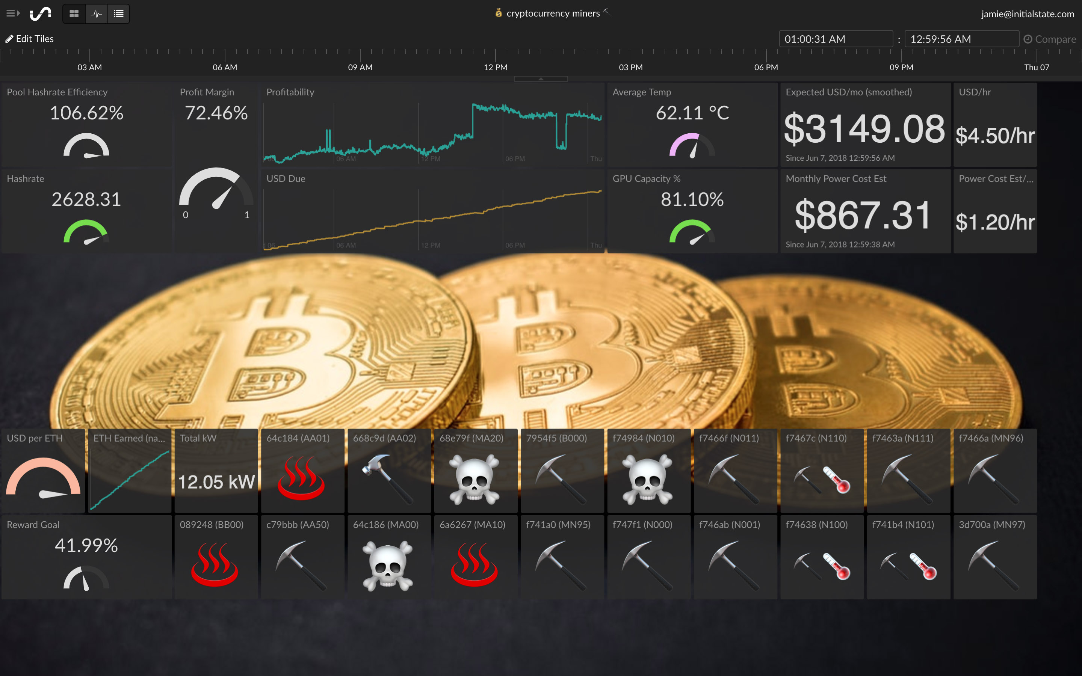

Initial States is a platform where users can gather, examine, and display data from a variety of sources, including Internet of Things (IoT) devices, with the aid of Initial State, a cloud-based platform for data streaming and visualization. Because of its reputation for handling real-time data and producing dashboards that can be customized, it is widely used by developers, engineers, and data enthusiasts for data monitoring, analysis, and presentation. Real-time data streaming from sensors, IoT devices, and other sources is possible with Initial State.

Numerous data inputs are supported by the platform, such as webhooks, REST APIs, and integrations with platforms such as Raspberry Pi. With customizable widgets like meters, bar graphs, line charts, heatmaps, and more, you can create interactive dashboards. Dashboard layouts, colors, and themes can all be changed to suit specific needs. To track multiple datasets at once, users can create multiple dashboards. Alerts can be set up according to data limits. When certain criteria are met, such as a temperature sensor surpassing a limit, the system can, for instance, send notifications. Emails, SMS, or system integrations can be set up to be triggered by these alerts. The cloud stores the data that is gathered and sent to Initial State, allowing for remote access. It is made to manage large amounts of data with a focus on speed and reliability.

Some advantages of initial state is the ease of use, real time capabilities, customization, and cross platform access. With the advantages there are also disadvantages like pricing, its dependence on the internet, and the fact that its IoT focused which may not be ideal for non-IoT related data visualization. In conclusion initial state is a powerful tool for creating real time data visuals. Its ease of use and advanced features make it a very valuable platform.